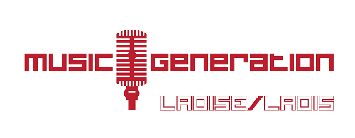
Application Form: Music Generation Laois Summer Programme 2018
Participant name:…………………………………………....................................Age:.............................
Address: …………………………………………………….............................................................................
……………………………………………………………….................................................................................
Parent/ Guardian Name …………………....................................Mobile:.........................................
Landline:..................................................................Email:........................................................
Summer Camp Title:
……………………………………………….....................................................................
Musical Experience (does your child play an instrument or sing? How many years has your child been playing an instrument for?):
..................................................................................................................................................
Any Medical Needs that the Music Generation Co-ordinator/Summer Camp Tutors should be aware of:……………………………………………………………………………………………………………………………………………
Photography/Video/Sound recording may be used for publicity and documentation purposes. Please tick this box if you DO NOT wish your child to take part in photography/video/sound recording for publicity and documentation purposes

Complete and return the application with payment by cheque/Postal Order made out to ‘Laois County Council’ and post to Music Generation Laois, Laois County Council, Áras an Chontae, Portlaoise, Co Laois
Or, in Person, at the Cash Office, Laois County Council, Áras an Chontae Portlaoise, Co Laois
Or by telephone, to Music Generation Laois on 057 8664176
Please use the Code AR022 when making payment. For further information contact Music Generation Laois on 057 8664176 or musicgenerationlaois@laoiscoco.ie

