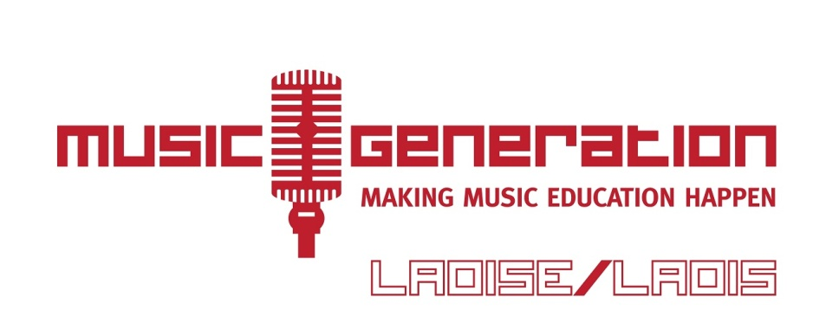

**School of Rock and Pop Keyboard Tutor Further Information:**

Music Generation Laois is a performance music education service for children and young people in Co Laois, based in Laois County Council. Music Generation Laois is part of Music Generation – Ireland’s National Music Education Programme, initiated by Music Network and co-funded by U2, The Ireland Funds together with, The Department of Education and Skills and Local Music Education Partnerships. Locally, Music Generation Laois is funded by Laois County Council (lead partner), Laois-Offaly Education and Training Board and Laois Partnership Company.

Music Generation Laois established a School of Rock and Pop in September 2013, which includes weekly tuition in guitar, keyboard and drums, weekly junior and senior jam times, performance, song writing and recording opportunities and an annual week long Summer School of Rock and Pop in the Dunamaise Arts Centre.

Music Generation Laois is now seeking submissions from experienced Keyboard Tutors to join the School of Rock and Pop team.

**Qualifications and Experience:**

* A high standard of performance in the genres of rock and pop is essential
* A proven track record in individual and group instrumental teaching is essential
* A qualification in music/music education is desirable
* Experience of leading a multi-instrumental ensemble is desirable
* Evidence of commitment to continuing professional development in the area of music education/ leading ensembles/ performance is desirable

**Person Specification:**

* Demonstrates a strong passion for teaching and learning, and for nurturing and inspiring the musical development of children and young people of all ages and abilities
* Demonstrates a commitment to high standards of teaching and learning for children and young people
* Demonstrates appropriate practical skill relevant to instrumental tuition and individual/group tuition
* Demonstrates the capacity to motivate and inspire children and young people, their parents/guardians, and the wider community about music education
* Has excellent communication, planning and organisational skills
* Demonstrates an ability to set teaching and learning objectives, monitoring and assessment strategies
* Demonstrates an understanding of artistic and education issues in developing access to music education
* Demonstrates an understanding of the ethos of Music Generation, both at a local level, in terms of the planned programmes for Music Generation Laois, and nationally
* Demonstrates openness to learning and an ability to be flexible in his/her approach to learning and teaching (working on own initiative and as part of a team)
* Demonstrates a commitment to continued professional development (CPD)

**Locations:** This programme will be delivered in Portlaoise

**Hours:** Various, as and when required, including weekends and school-holiday time. Some opportunities may arise for Music Tutors to lead a particular programme. Ensemble Leadership opportunities, and collaborative performance opportunities for ensembles may also arise.

**Probation:**

Successful candidates will serve a probation period

**Rate of Pay:**

Hourly Rate for Music Tutor Contracts: €32.50 per hour

Contract for services opportunities may also arise, for which a fixed-term contract will be offered.

**Child Protection:**

All Music Tutors will be subject to Garda Vetting and Child Protection Training

**Reporting to:**

Music Generation Laois Co-ordinator

**Interviews:**

Provisional date for interviews is **Tuesday 26 September 2017**

**Closing Date for Receipt of Submissions:**

Completed submission forms must be received by **5pm,** **Thursday 21 September 2017** Submission Forms can be submitted electronically by email to rflannery@laoiscoco.ie

**Further information:**

Further information can be requested by email rflannery@laoiscoco.ie or Telephone 057 8664176





